长沙民政职业技术学院

**毕业设计**

**题目**：

|  |  |  |
| --- | --- | --- |
| **产品设计** | **工艺设计** | **方案设计** |
|  |  | **√** |

**类型：**

**学生姓名：**

**学 号：**

**学 院： 软件学院**

**专 业： 计算机网络技术**

**班 级： CNT 2231**

**学校指导教师：**

**企业指导教师：**

**年 月 日**

**长沙民政职业技术学院毕业设计独创性声明**

秉承严谨的学风和研风，本人声明所提交的毕业设计是本人在指导老师指导下所取得的成果。我承诺：本人毕业设计除了特别标注和致谢的内容外，毕业设计中未涉及抄袭、委托他人代写、剽窃、伪造、篡改、不当署名、一稿多投、重复发表、违背研究伦理等其他学术不端行为，为本毕业设计做出贡献的个人和集体，均已在毕业设计中明确并致谢。

如违反上述声明，本人愿承担一切相关责任。

作者签名：

日期：

# ****Kongphon Store: Final Year Project Documentation****

## ****1. Introduction****

### ****Project Overview:****

Kongphon Store is a fully functional e-commerce platform designed to sell a variety of technology products. The website includes a user-friendly interface, secure payment methods, and an engaging user experience that aligns with modern web design principles. This project aims to showcase both technical proficiency in web development and an understanding of business functionality in an e-commerce setting.

### ****Project Objectives:****

* Develop an online store that sells tech products such as wireless headphones, mobile accessories, and smart home devices.
* Integrate essential features like product browsing, cart functionality, user registration/login, and a secure checkout process.
* Implement responsive design to ensure the site is accessible on both desktop and mobile devices.
* Provide a seamless and secure experience with proper data protection for customers.

## ****2. Project Scope and Features****

### ****Scope of the Project:****

This project focuses on creating a robust, scalable, and secure e-commerce platform. The scope includes the development of a front-end for product browsing, as well as a back-end to manage inventory and handle user accounts.

### ****Key Features:****

* **User Registration and Login:** Secure user authentication using email/password.
* **Product Pages:** Detailed product descriptions, images, and an option to add items to the shopping cart.
* **Shopping Cart:** Users can add, view, or remove items in their cart before proceeding to checkout.
* **Secure Checkout System:** Integration with a payment gateway for secure transactions.
* **Responsive Design:** The website is fully responsive and works seamlessly on all devices (desktop, mobile).
* **Admin Panel (Optional):** A back-end dashboard for managing products, user accounts, and order history.

### ****Website Screenshots:****

Here are the key screenshots of the website, illustrating the main features:

#### ****Homepage Screenshot:****

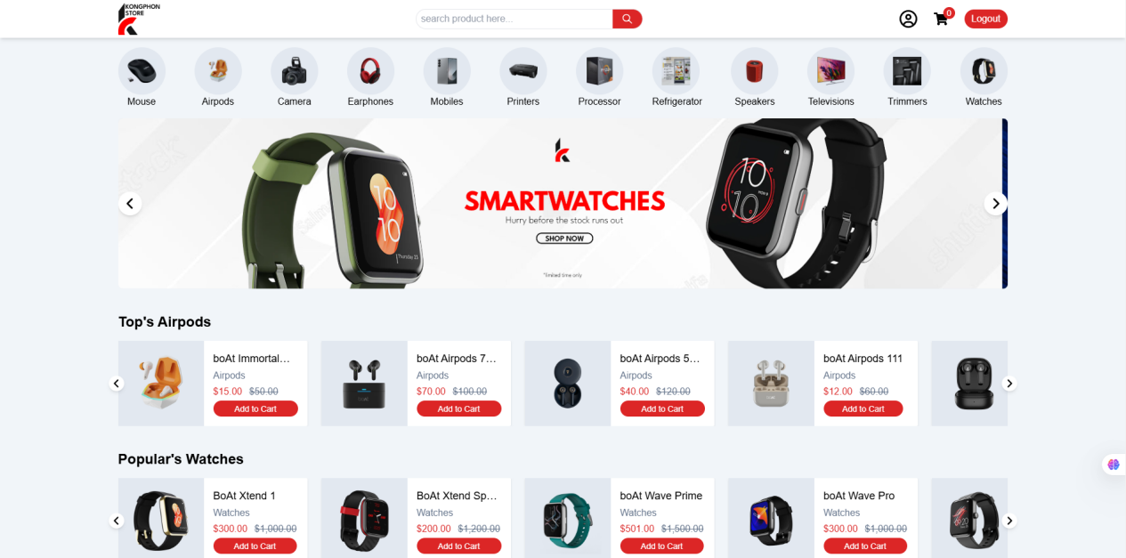

The homepage displays featured products, promotional banners, and easy navigation to the product categories. It has a clean layout with prominent call-to-action buttons.

#### ****Product Page Screenshot:****

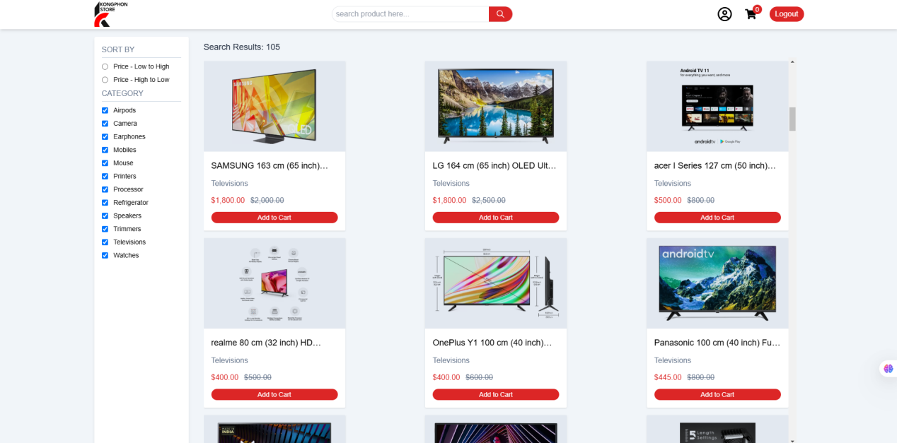

Each product page includes high-quality images, detailed descriptions, and a purchase button. Users can also view customer reviews and product specifications.

#### ****Shopping Cart Screenshot:****

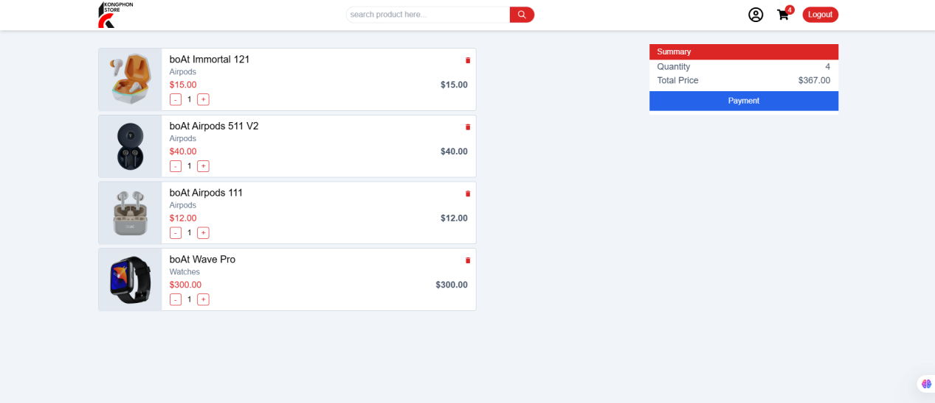

The shopping cart allows users to review their selected products before proceeding to checkout. It includes options to update quantities or remove items.

#### ****Single Product Screenshot:****

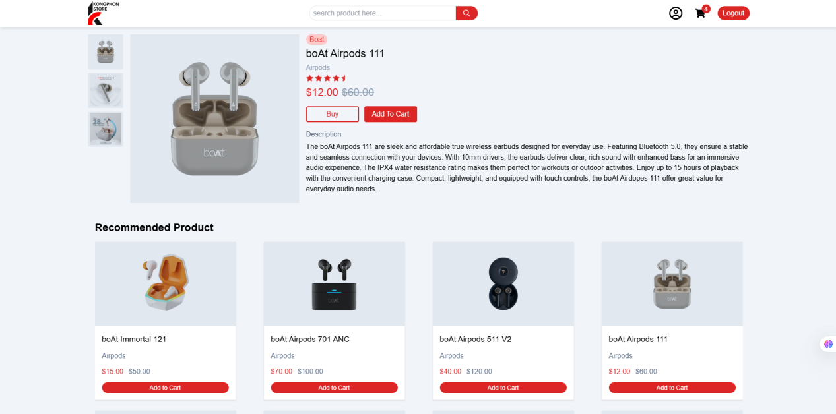

A streamlined checkout page with multiple payment options and a summary of the user’s order.

#### ****Checkout Page Screenshot:****

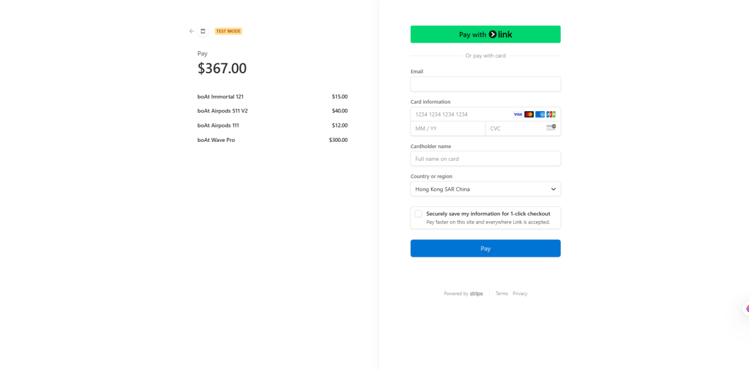  
A streamlined checkout page with multiple payment options and a summary of the user’s order.

## ****3. Technology Stack and Development Tools****

### ****Front-End Technologies:****

* **HTML5:** For the structure of the web pages.
* **Tailwind CSS:** For styling the pages and ensuring a responsive design.
* **JavaScript:** To create interactive elements like the shopping cart and form validation.
* **React/Vue.js :** For building dynamic user interfaces with reusable components.

### ****Back-End Technologies:****

* **Node.js:** For handling server-side logic and building the API.
* **Express.js:** To manage routing and server requests.
* **MongoDB:** A NoSQL database to store user accounts, product information, and order details.
* **Mongoose:** A MongoDB ODM to interact with the database more easily.
* **JWT (JSON Web Tokens):** For secure user authentication.
* **Cloudinary:** For uploading the product files.

### ****Payment Integration:****

* **Stripe API (or PayPal):** For integrating secure payment options.

## ****4. Development Process and Implementation****

### ****1. Project Planning:****

The initial phase involved planning the project layout and identifying core functionality. A mainframe and site structure were created to map out user interactions, ensuring a smooth flow from browsing to checkout.

### ****2. Front-End Development:****

The front-end of the website was developed using HTML, CSS, and JavaScript. A responsive design was implemented using media queries to ensure that the site functions well across various screen sizes.

* **Navigation Bar:** A sticky navbar allows easy access to product categories, the shopping cart, and the user profile.
* **Product Display:** Dynamic content such as product names, prices, and images is fetched from the database and displayed on the website using JavaScript.

### ****3. Back-End Development:****

The server-side logic was implemented using Node.js and Express.js. Key functionalities include:

* **User Registration/Login:** Implemented using JWT for secure authentication.
* **Product Management:** Products are stored in MongoDB, and users can browse products by category or search by name.
* **Cloudinary:** For uploading the photos of the product.
* **Order Processing:** Users can place orders, which are stored in the database along with order details.

### ****4. Integration:****

The website was integrated with the Stripe API for secure payment processing. The system also handles order confirmation, generating receipts for users after a successful transaction.

## ****5. Challenges Faced and Solutions****

### ****Challenge 1:**** Responsive Design

Making the website look good across various devices was a challenge.  
**Solution:** Utilized CSS media queries to adjust the layout and font sizes based on the screen size.

### ****Challenge 2:**** Secure User Authentication

Ensuring that user data was kept safe and the login system was secure was a major concern.  
**Solution:** Used JWT tokens for authentication, encrypting passwords with bcrypt.

### ****Challenge 3:**** Payment Gateway Integration

Integrating a payment gateway was tricky as it involved handling sensitive user data.  
**Solution:** Used Stripe's secure API for payment processing and ensured compliance with PCI DSS standards.

## ****6. Testing and Quality Assurance****

Testing was conducted throughout the development process to ensure functionality and identify bugs. This included:

* **Unit Testing:** For individual functions and features.
* **Integration Testing:** To test the interaction between the front-end and back-end.
* **User Testing:** Gathering feedback from users to ensure the website is easy to navigate and functional.

## ****7. Future Improvements****

* **Mobile App Version:** Developing a mobile application for better user experience.
* **Admin Panel:** A back-end dashboard for store managers to update products, view orders, and manage users.
* **SEO Optimization:** Improving search engine rankings to increase visibility.

## ****8. Conclusion****

Kongphon Store successfully meets the objectives outlined in the project proposal. It is a fully functional e-commerce platform designed to sell tech products, with secure user authentication, a responsive design, and a secure checkout system. This project demonstrates proficiency in web development, database management, and integrating third-party services such as payment gateways.